Parking App Project
- According to my research, I found that there already exists applications that will allow you to pay for parking online, typically by scanning a QR code. Some examples of these applications would be PayByPhone and EasyPark. I found that PayByPhone is introducing a feature that allows users to see lots that have parking available and reserve parking spots ahead of time. However, this is a new feature that is only supported by specific venues and is only available in select states in the United States. This feature also does not allow users to choose specific parking spaces. EasyPark also has a similar feature, but it is limited to the same restraints as PayByPhone. In contrast to these applications, my application will have the ability to show users exactly which parking spots are available in certain parking garages. This will also make it so that parking availability predictions within the app are more accurate.

- We acquired this project from the office of Harris County. They saw a need to facilitate parking and improve availability for their citizens. WE ARE $oftware ¢orp was chosen out of a selection of various corporations due to its unlimited resources and budget. ParkingWizard was then created to find a solution to this problem. We want to help users be able to more accurately see available parking and clear prices throughout the city. The software that we are hoping to build will allow users to find available parking garages on a map, see which specific spots are available within those garages, see accurate prices, and even be able to reserve a parking spot online.

SRS
1. Introduction
1.1 Purpose
The purpose of our parking app is to facilitate finding and reserving parking for drivers. The app will allow users to find parking garages, see available parking spaces, compare different prices, and reserve parking spots online. Parking garage operators will also be able to manually manage their availability and prices.
1.2 Scope
ParkingWizard will be an app that provides users with information about parking garages and individual spaces. The users will be able to search for specific locations, see which garages have availability, compare prices and time limits, reserve parking spaces, save their payment methods, view their reservation history/receipts, and get directions to the parking garage that they reserved a spot in. Parking operators will also be able to manage their parking information.
2. Overall Description
Users: drivers, parking operators, system admins, project team
System Environment: This will be a mobile application but will also be accessible on desktop
Constraints:
- Users need an internet connection
- Map and payment features will depend on external application integration
- Project has to be developed within the five month timeline
Assumptions: user has internet access, maps and payment will depend on external app integrations, our app must protect users’ personal and payment data
3. Functional Requirements
FR1: System allows new users to register with an email address and a password
FR2: System provides an email verification process
FR3: System lets users to log in and log out securely
FR4: System lets users manage their account information
FR5: System lets users to save and manage payment methods
FR6: System displays parking garages on an interactive map
FR7: System allows users to search for parking by entering a specific location in search bar
FR8: System displays availability of parking garages
FR9: System displays individual parking spaces and their availability
FR10: System shows prices for specific garages and any time limits
FR11: System lets users compare availability across different garages
FR12: System updates parking availability when new information is received from parking operators
FR13: System displays reservation details before the user finalizes the reservation
FR14: System prevents two users from reserving the same parking spot within the same garage at the same time frame
FR15: System holds a selected space while the user finalizes their reservation
FR16: System processes payments through the integrated external payment provider
FR17: System generates receipts after transactions are completed
FR18: System allows users to view their reservation history
FR19: System gives users directions to their reserved garage using the integrated external navigation service
FR20: System allows users to share their reservation details
FR21: System allows authorized operators to update their parking garage information
FR22: System shows operators a dashboard with parking occupancy
FR23: System saves reservation, payment, and other relevant activity for monitoring and troubleshooting purposes
4. Nonfunctional Requirements
NFR1: System should be able to support multiple users searching and making reservations at the same time without overloading servers
NFR2: Parking availability information should be updated and refreshed quickly
5. Use Case Examples
  - Creating an account
Primary Actor: User
Goal: Allow new user to create an account on the application.
Precondition: User does not already have an existing account
Steps:
1. User selects “Sign Up”
2. User enters their email and creates a password
3. User verifies their account via verification link sent to their email
Postcondition: User has an account
  - Logging in
Primary Actor: User
Goal: Allow existing user to access their account
Precondition: User has an existing account
Steps:
1. User selects “Log in”
2. User enters the email and password they used to create the account.
3. User selects “Log in” again at the bottom of the page
Postcondition: User successfully logs into their existing account
  - Saving payment methods onto the user account
Primary Actor: User
Goal: Allow for users to save payment methods onto their account for future transactions
Precondition: User has an account, is logged in, and their payment method is valid
Steps:
1. User logs into their account
2. User goes to the “My Account” page
3. User selects “Payment Methods”
4. User selects “Add Payment Method”
5. User enters valid card information
6. System validates and saves the card information onto user account
Postcondition: Payment method is successfully saved onto the user account
  - Searching for a specific location in the search bar on the map page
Primary Actor: User
Goal: Allow for user to find the location they are looking for in the map page
Precondition: User has an account, user is in the map page
Steps:
1. User clicks on the map page
2. User clicks on the search bar at the top of the map page
3. User enters a specific & valid location address
4. User presses “Search”
5. System processes the query
6. System displays the location on the map
Postcondition: The location that was searched for shows on the map
  - Viewing garages that have available parking
Primary Actor: User
Goal: Allow users to see which garages have parking spots available
Precondition: User has an account and is in the map page
Steps:
1. User scrolls through different map areas.
2. System identifies garages with available space
3. System shows user said garages
Postcondition: User is able to identify available parking garages
  - Viewing specific parking spaces within those garages
Primary Actor: User
Goal: User
Precondition: User has selected an available parking garage
Steps:
1. User selects an available garage
2. System accesses available parking spot information
3. System displays said information
Postcondition: User is able to view specific spaces within the garage they selected
  - View pricing for different garages from the map page
Primary Actor: User
Goal: Allow users to view prices to park in different garages
Precondition: User is in the map page
Steps:
1. User scrolls through the map page
2. System pulls pricing information from the garages within the user’s current search area
3. System displays said information
Postcondition: User is able to view pricing information for different garages at once
  - View time limits for parking spots in different garages
Primary Actor: User
Goal: Allow users to see how much time they can park in a garage for
Precondition: User has selected a parking garage
Steps:
1. User selects parking garage
2. System pulls up any time constraint information for that garage
3. System displays the information it pulled
Postcondition: User is informed of the time limit for the garage that they selected
  - Compare amount of available parking spots within different garages.
Primary Actor: User
Goal: Allow users to compare availability among different parking garages
Precondition: User is in the map page, user has selected multiple garages
Steps:
1. User selects various garages
2. System pulls up availability for all selected garages
3. System displays information it pulled for all of the garages
Postcondition: User is able to compare availability between different garages
  - Reserve parking spaces
Primary Actor: User
Goal: Allow users to reserve available parking spots
Precondition: User is logged into their account, selected garage has availability, and user has selected a specific parking spot
Steps:
1. User selects a garage
2. User selects parking space
3. User selects reservation time
4. System displays reservation details for user confirmation
5. User confirms the information
Postcondition: A parking space is held for the user for a short period of time until payment is received
  - Pay for said parking spaces
Primary Actor: User
Goal: Allow users to pay for parking spaces within the garage they selected
Precondition: User is logged in, user has selected a parking reservation, and they have a valid payment method
Steps:
1. User reviews the reservation method that was generated in the previous use case
2. User selects a payment method
3. System validates payment information
4. Payment provider processes transaction
5. System gives user payment confirmation
Postcondition: User successfully pays for their parking reservation
  - Receive directions to get to the reserved parking garage.
Primary Actor: User
Goal: Allow user to receive directions to get to their parking reservation
Precondition: User has a parking reservation
Steps:
1. User accesses their parking reservation
2. User clicks “Get Directions”
3. User selects preferred navigation platform (Google Maps, Apple Maps, Waze, etc)
3. System pulls the parking garage’s location information
4. System launches the preferred navigation platform with the parking garage location pulled up
Postcondition: User is able to receive directions to their parking garage
  - View reservation receipts
Primary Actor: User
Goal: Allow users to access existing receipts for their parking reservations
Precondition: User is logged into their account and has reserved a parking garage in the past
Steps:
1. User opens their reservation history page
2. User selects a reservation that was paid for and confirmed
3. System pulls the receipt associated with that reservation
4. System displays said receipt for the user
Postcondition: User is able to view the receipt associated with a specific transaction
  - Share reservation with other people
Primary Actor: Driver
Goal: Allow users to share their reservation information with other people
Precondition: User has a confirmed reservation
Steps:
1. User accesses their reservation
2. User clicks “Share”
3. System generates a sharable version of the selected reservation
4. User selects a sharing method
Postcondition: User is able to share their reservation information with other people
  - View all past reservations made in the account
Primary Actor: User
Goal: Allow user to view previous paid reservations associated with their account
Precondition: User is logged in and has made a reservation before
Steps:
1. User clicks “My Account”
2. User clicks “Reservation History”
Postcondition: User is able to view their reservation history

User Stories
“As a new user, I want to create an account so that I can see and reserve parking spots.”
Acceptance Criteria:
- Can enter an email and create a password
- System can verify the user’s email
- User’s password is not already taken
- Account is created
“As a driver, I want to search for parking by location so that I can find garages near my destination.”
Acceptance Criteria:
- User can enter a location
- Relevant garages show up on the map
- User is able to select a specific garage
“As a driver, I want to see specific parking spaces within a garage so that I can choose where I want to park.”
Acceptance Criteria:
- System displays available spaces
- Specific space availability is updates when new information is received
- Any spaces that are unavailable are clearly identified
“As a driver, I want to compare prices between garages so that I can choose the cheaper relevant option.”
Acceptance Criteria:
- Garage prices are displayed
- User is able to compare multiple different garages
“As a driver, I want to reserve a specific parking space for the selected time that I need.”
Acceptance Criteria:
- User is able to select a space that is available at a specific time slot.
- System shows reservation details before finalization
- User is able to successfully reserve the chosen parking spot at the chosen time slot
“As a driver, I want to view receipts for all of my reservations so that I can keep track of my expenses.”
Acceptance Criteria:
- User can access reservation history
- Completed transactions have generated receipts
“As a driver, I want directions to my reserved garage so that I can easily get there.”
Acceptance Criteria:
- Reservation displays the garage location
- User can choose their preferred navigation application
- Directions for the specified garage open correctly in the chosen navigation application
“As a parking operator, I want to update parking availability for my garage.”
Acceptance Criteria:
- Authorized parking operators can update availability status
- Changes correctly appear in the system
- Unavailable parking spots cannot be booked”
“As a parking operator, I want to update parking prices so that the displayed rates accurately reflect current prices”
Acceptance criteria:
- Authorized operator can edit parking prices for their own garages
- Updated prices are saved in the system
- Users are able to see the updated price
“As a parking operator, I want to view garage occupancy so that I can use it for my records/reports.”
Acceptance Criteria:
- Operator dashboard shows occupancy information
- Information reflects the latest updated data
“As a parking operator, I want to view parking revenue reports so that I can keep track of income from reservations on this app.”
Acceptance Criteria:
- System is able to generate a revenue report for the specified operator
- Report can be reviewed for a selected period
- Report uses saved transaction data from users
“As a system admin, I want to manage account permissions so that only authorized people are able to access restricted features.”
Acceptance Criteria:
- User roles determine permissions
- Unauthorized users are not able to access operator functions

Work Breakdown Structure
1. Project Planning
1.2 Define Project Scope
1.3 Develop Project Schedule
1.4 Develop Project Budget
1.5 Identify Project Risks
2. Project Coordination
2.1 Team Coordination
2.2 Progress Meetings
2.3 Status Reporting
3. Project Documentation
3.1 SRS Documentation
3.2 Project Management Documentation
3.3 Final Project Documentation
4. Stakeholder Analysis
4.1 Identify Drivers
4.2 Identify Parking Operators
4.3 Identify City Transportation Stakeholders
4.4 Identify Payment Providers
4.5 Identify System Administrators
5. Requirements Elicitation
5.1 Gather Driver Requirements
5.2 Gather Operator Requirements
5.3 Gather Administrative Requirements
5.4 Identify External Integration Requirements
6. User Interface Design
6.1 Mobile Application Design
6.2 Web Application Design
6.3 Map Interface Design
6.4 Reservation Interface Design
7. System Architecture
7.1 Backend Architecture
7.2 Database Architecture
7.3 API Architecture
7.4 Security Architecture

Timeline/Gantt Chart
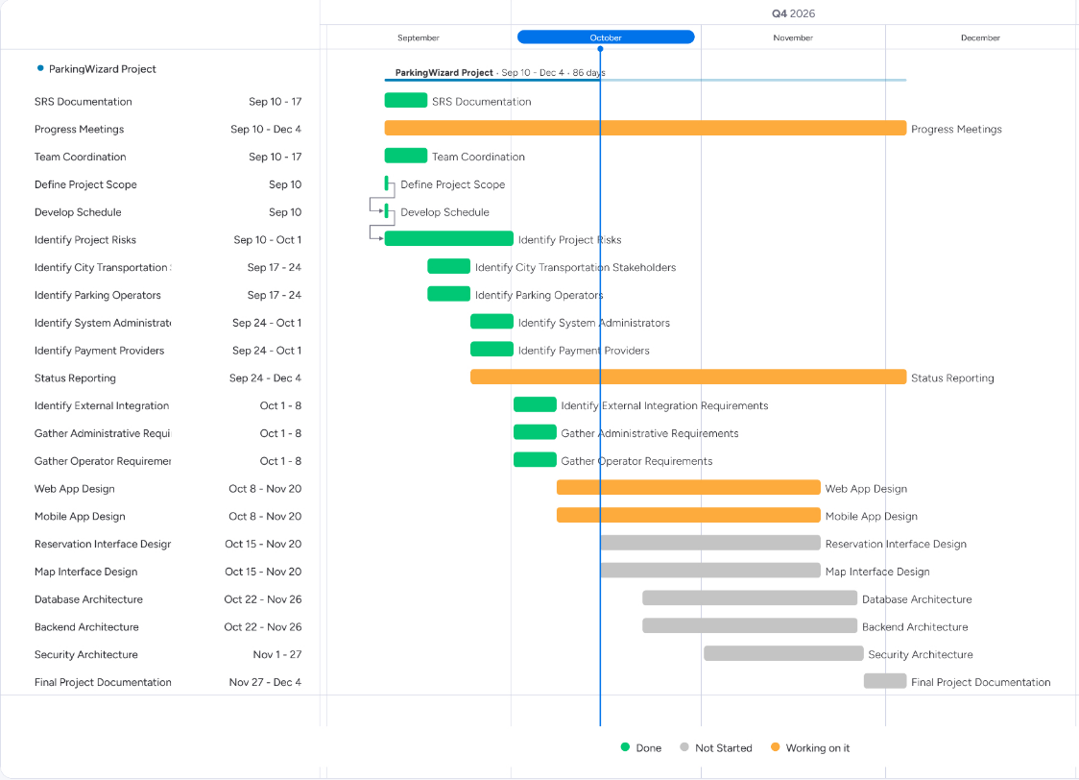

Backlog (HWK 3)
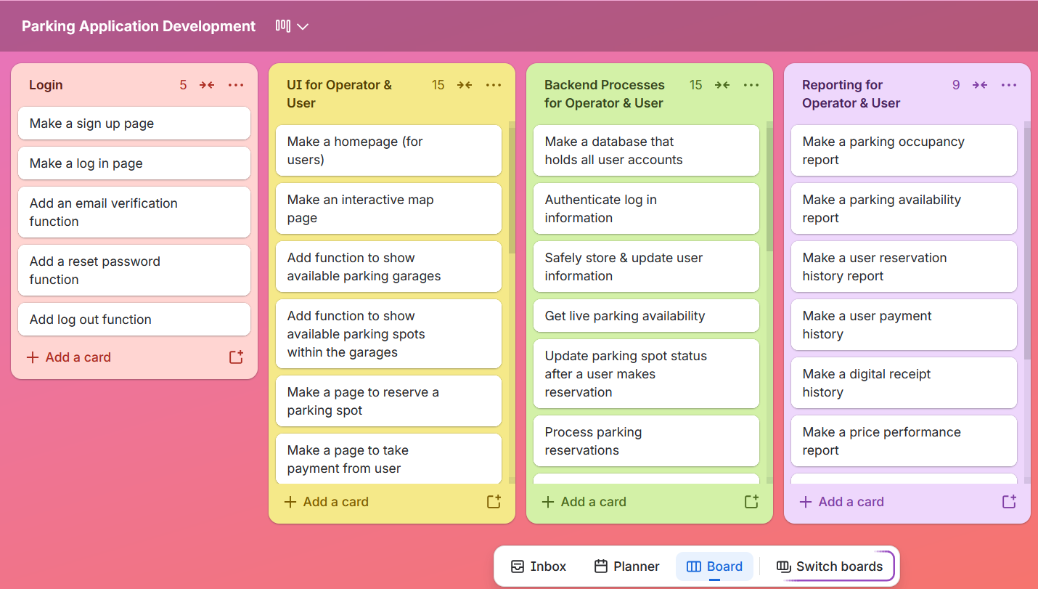
Backlog organization:

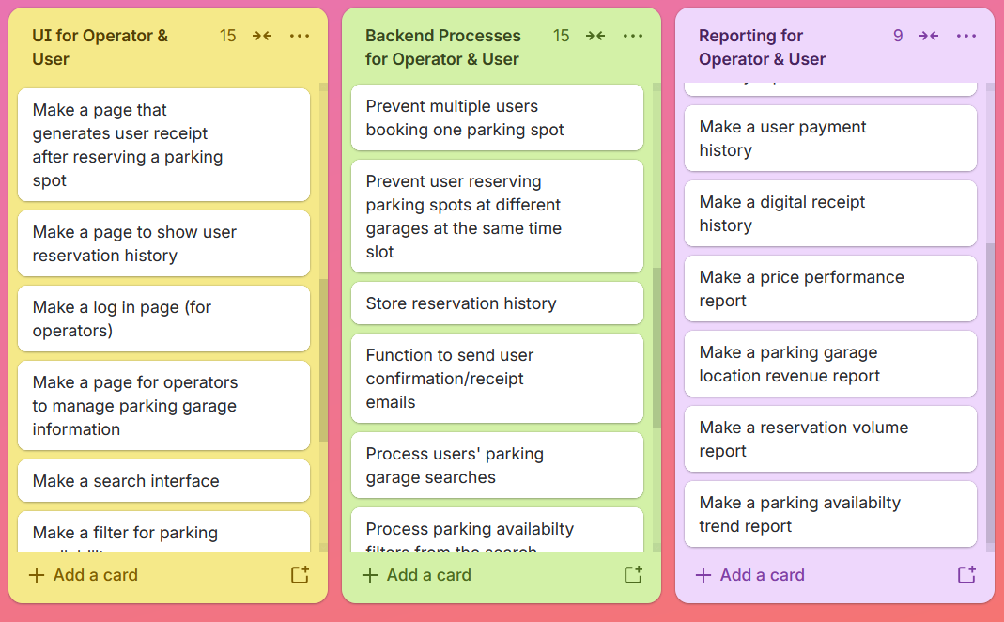
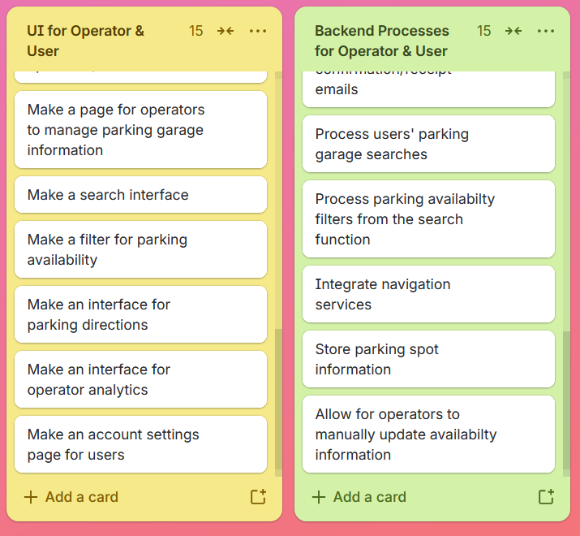
Sprint planning: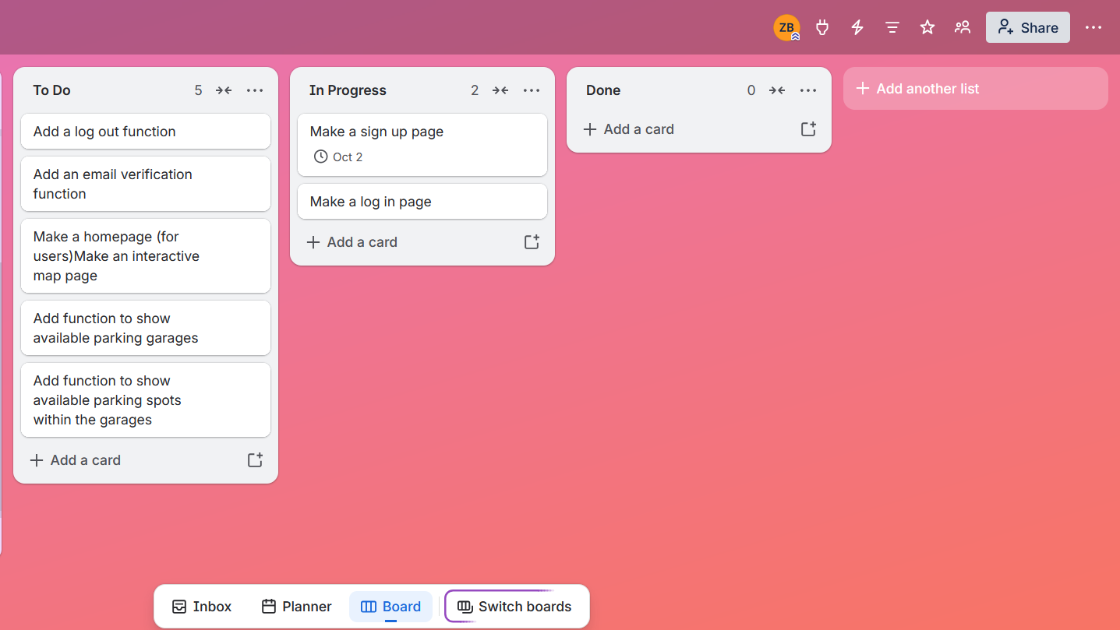
Risks (HWK 4)
Some technical risks that I can foresee taking place:
- Security issues
- Real time availability problems
- Third party integration issues
- Database issues
Some schedule issues that I can foresee taking place:
- Testing delays
- Development takes too long
- Work overload in one sprint
- Third party delays
Some financial issues that I can foresee taking place:
- Cost to implement third party services
- Maintenance costs
- More resources needed during development
- Infrastructure costs
Some people issues that I can foresee taking place:
- Communication issues
- Differences in skill levels
- Limited availability
- Team members not getting along
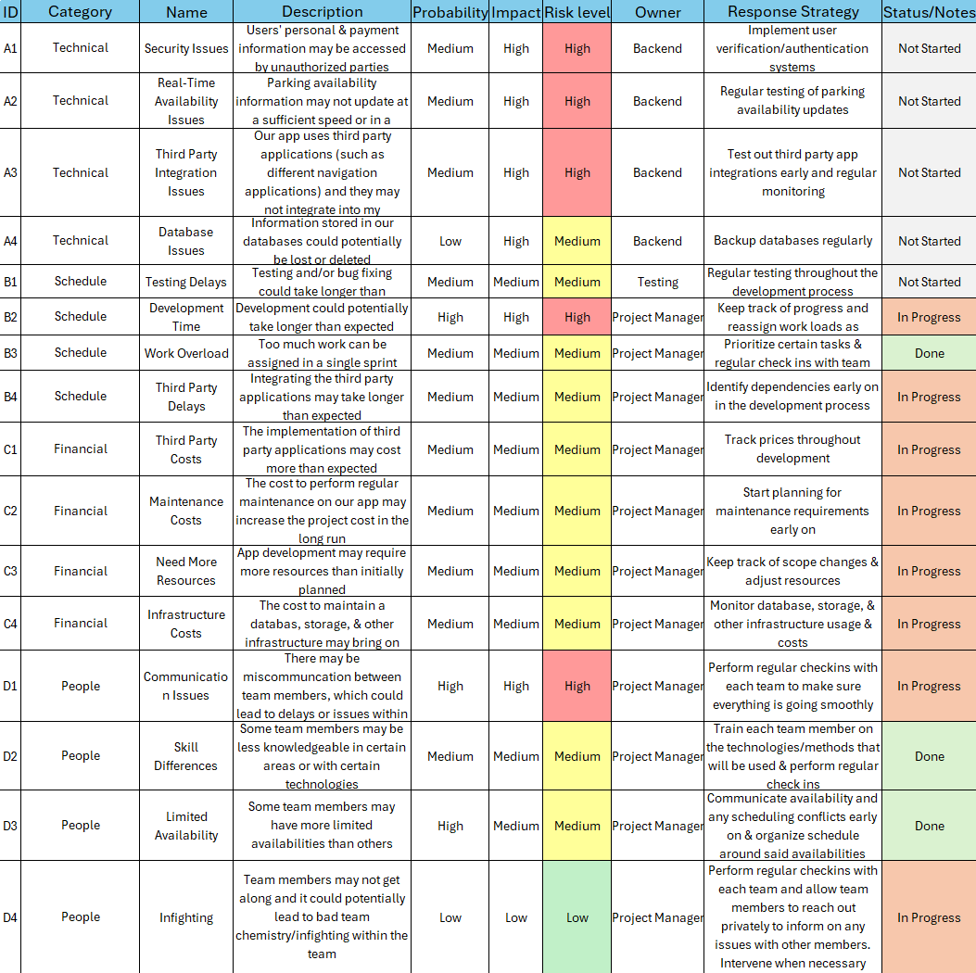
Risk Register:

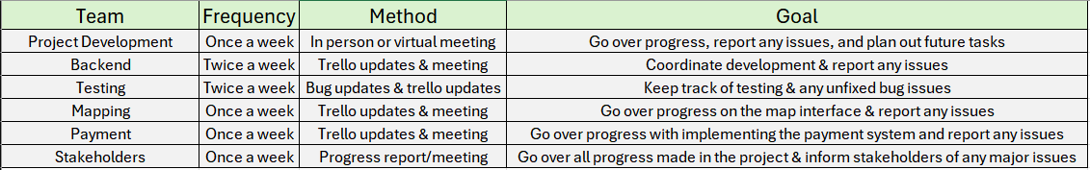
Communication Plan:

Homework 5
Roles & Resources
Developers: Amina Turner; Senior (10 years of experience); 100%
Hayden Choi; Senior (8 years of experience); 100%
Ibrahim Hadid; Senior (13 years of experience); 100%
Project Manager: Freddy Lee; Senior (15 years of experience); 50%
Quality Assurance: Andrea Martinez; Junior (2 years of experience); 50%
Stanley Boyle; Mid Level (3 years of experience); 50%
UX: Ameer Ali; Mid Level (4 years of experience); 75%
DevOps: Hector Ortega; Senior (8 years of experience); 50%
Nicole Cuevas; Senior (10 years of experience); 50%
Business Analyst: Jennifer Bodine; Mid Level (5 years of experience); 80%
Product Owner: Brandon Nguyen; Senior (10 years of experience); 100%
Subject Matter Expert: Victoria Goodwin; Senior (13 years of experience); 25%
Resource & Cost Plan (Bottom-Up):
Parking Application (12 people, 5 months) – worked bottom-up:
Assumptions:
- PM: 1 * (800 hours * $50/hr) = 1 * 40,000 = 40,000
- Developers: 3 * (800 hours * $70/hr) = 3 * 56,000 = 168,000
- QA: 2 * (800 hours * $40/hr) = 2 * 32,000 = 64,000
- UX: 1 * (600 hours * $50/hr) = 1 * 30,000 = 30,000
- DevOps: 2 * (800 hours * $60/hr) = 2 * 48,000 = 96,000
- Business Analyst: 1 * (800 hours * $45/hr) = 1 * 36,000 = 36,000
- Product Owner: 1 * (800 hours * $55/hr) = 1 * 44,000 = 44,000
- Subject Matter Expert: 1 * (100 hours * $40/hr) = 1 * 4,000 = 4,000
Labor Subtotal: 40,000 + 168,000 + 64,000 + 30,000 + 96,000 + 36,000 + 44,000 + 4,000 = $482,000
Infrastructure & Other Costs = Cloud $6,000/month * 5 = $30,000; Third Party Applications $3,000; Licenses $10,000; Security $30,000; Training $5,000; Hardware $7,500 -> subtotal = $85,500
Overhead/Benefits (30% of labor) = 0.30 * $482,000 = $144,600
Total Before Contingency = $482,000 + $85,500 + $144,600 = $712,100
Contingency (15%) = 0.15 * $712,100 = $106,815
Grand Total = $712,100 + $106,815 = $818,915 (~819K)
Cashflow:
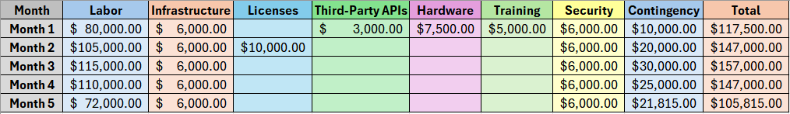
RACI Matrix:
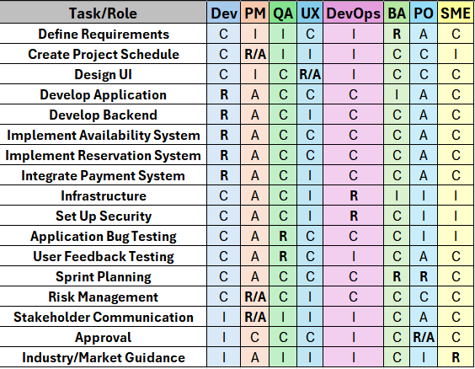

Power Interest Grid
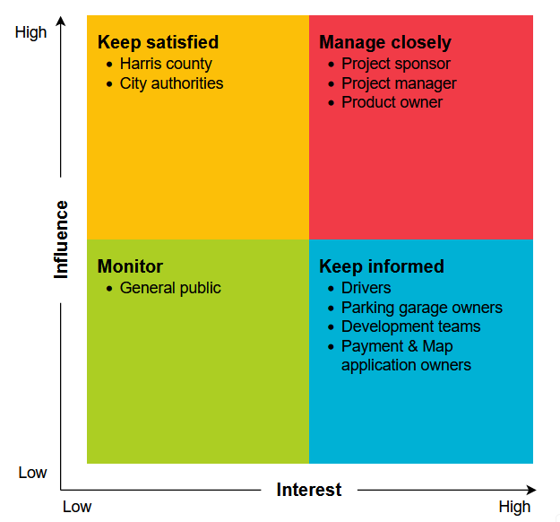

Team Charter
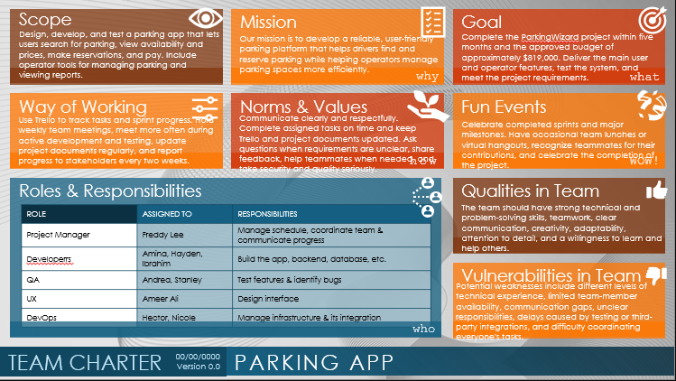

Project Closure Report (HWK 8)
Executive Summary
The ParkingWizard project was developed to create a parking platform that facilitates finding and reserving parking for drivers. The application is made to let users search for specific parking garages, see available spaces and prices, and make reservations. It also allows parking garage operators to manage their facilities within the app and view their data reports.
Throughout this project, our team worked on requirement identification, organizing backlogs, sprint planning, developing project management documents, etc. Some of the project management documents that we made include the team charter, risk register, cost estimate, and the RACI matrix. This project was organized around a five month set timeline with a budget of approximately $819,000.
Achievements and Shortfalls
Achievements
Our team identified the requirements and major features that would be needed for the development of this application. Some use cases were created to help explain important functions, such as account creation, parking searches, viewing availability, reservations, making payments, etc. Our team also developed a backlog that covered login, backend development, user interface, and reporting. A sprint plan was made to organize all of our tasks and help create a timeline for when these tasks should be done. Creating these documents helped the team establish the project goals, each group’s responsibilities, and the resources that would be needed to finish this project.
Shortfalls
The main shortfall that we encountered while working on this project was meeting our set deadlines. There were multiple delays in our work that caused us to miss some of our deadlines. Another shortfall was the platform’s dependence on the third party mapping and payment applications. The main reason being that if the external applications were experiencing any issues or outages, it would affect our parking application as well.
Lessons Learned
One important lesson that was learned was the importance of planning and organizing before even beginning development. Creating use cases, the work breakdown structure, and the sprint planning helped us identify what needed to be done and how everything should be organized.
Another lesson that we learned was how important communication is between team members and between each team. Keeping everyone updated on setbacks or progress via teams meetings and Trello helps to prevent any possible confusion or miscommunication between teams.
Recommendations for Future Plans
For future projects, teams should mainly focus their efforts on creating and testing the most important user features first. These can be things that may seem basic, such as account creation, login, dashboards, etc. While these may seem simple at first, teams should prioritize working on these in the beginning stages, as they are the main things that the users will be interacting with. Eliminating any problems that arise with these features in the beginning stages helps to avoid failures later on in the project.
Another recommendation is for projects that work with third party app integrations or cloud storage to set aside some of their budget for these assets and secure the rights to use these tools in the beginning stages of development. Doing so can help avoid delays due to licensing issues in the future.
Recommendations for our project in the future would include performing regular maintenance of the application in order to ensure that everything is working correctly and efficiently. The team could also work with more parking operators in order to bring more parking locations to the application.
Conclusion
The ParkingWizard project worked to plan out the development of a parking application. Good planning strategies, along with risk assessments, and team communication helped this project come to fruition. Continuing to apply these methods and strategies in future development and testing will give way to a successful project.

